FCDrive8800.Dll 动态库是ActiveX动态库，使用前需要先注册。或者安装一卡通软件，安装时会自动注册。

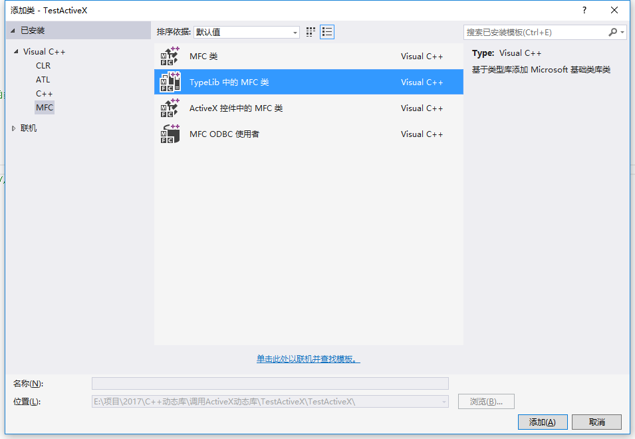

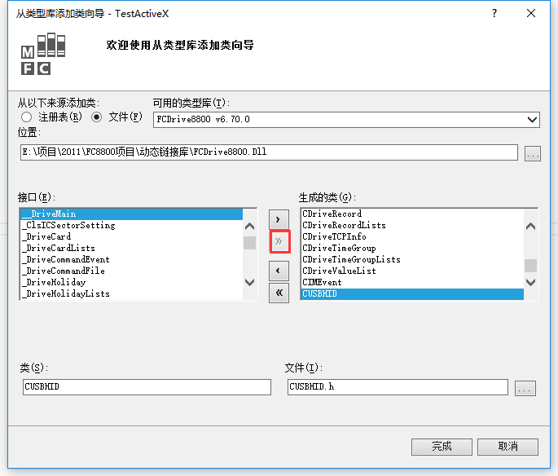

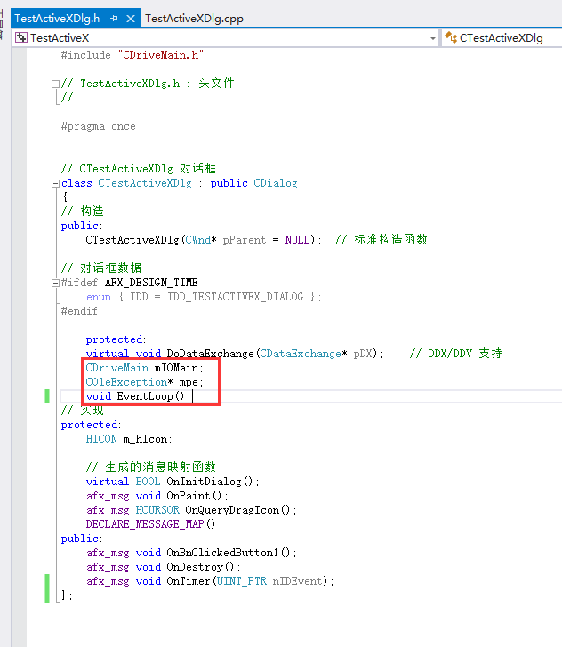

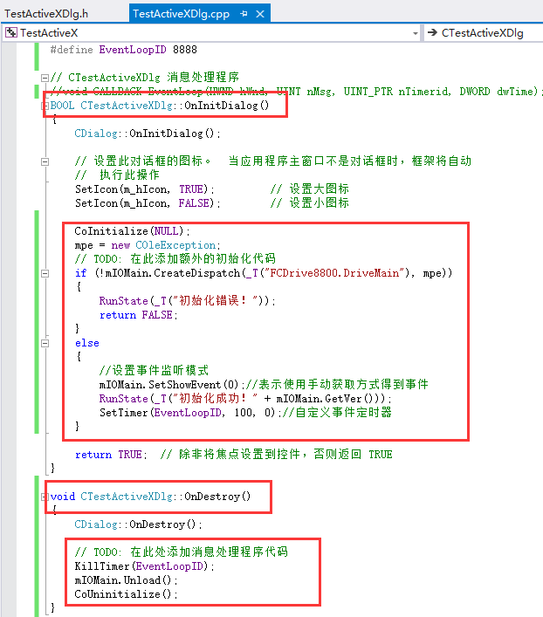

示例代码：

void CTestActiveXDlg::EventLoop()

{

do

{

CDriveCommandEvent myevent = (CDriveCommandEvent)mIOMain.GetEvent();

if (myevent != NULL)

{

long iType = 0;

iType = myevent.get_EventType();

switch (iType)

{

case 1://vbFrameAchieve

RunState(_T("命令成功！"));

break;

case 4://vbCommandTimeout

RunState(_T("命令超时！"));

break;

case 7://vbOpenPortErr

RunState(_T("IP地址或端口错误！"));

break;

case 12://vbPasswordErr

RunState(_T("通讯密码不正确！"));

break;

default:

break;

}

}

else

{

return;

}

} while (true);

}

void CTestActiveXDlg::OnBnClickedButton1()

{

CDriveInfo oInfo;

if (!oInfo.CreateDispatch(_T("FCDrive8800.DriveInfo"), mpe))

{

RunState(_T("创建 DriveInfo 错误！"));

return;

}

oInfo.put_SN(_T("FC-8940A46060007"));

oInfo.put_Password(_T("FFFFFFFF"));

oInfo.put_EquptType(8);//门禁控制器

oInfo.put_ConnType(1);//OnTCP

oInfo.put_IP(_T("192.168.1.169"));

oInfo.put_NetPort(8000);

CDrivePortList door;

door.CreateDispatch(_T("FCDrive8800.DrivePortList"), mpe);

door.SetEquptType(8);//设定为门禁控制器

door.SetPortValue(1, 1);//设定开1门

mIOMain.OpenDoor((LPDISPATCH*)&oInfo, (LPDISPATCH*)&door);

}

void CTestActiveXDlg::OnTimer(UINT_PTR nIDEvent)

{

// TODO: 在此添加消息处理程序代码和/或调用默认值

if (nIDEvent == EventLoopID)

{

KillTimer(EventLoopID);

EventLoop();

SetTimer(EventLoopID, 100, 0);

}

CDialog::OnTimer(nIDEvent);

}